Northstar Irish Wolfhound Club
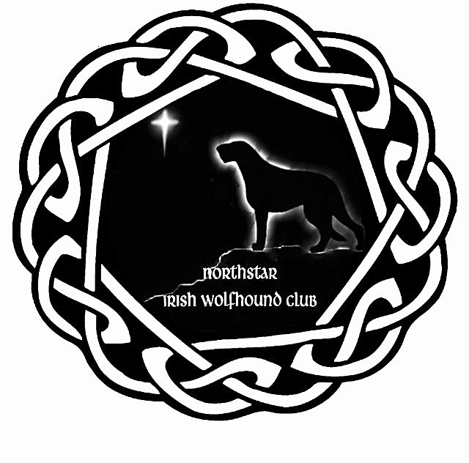
ACTIVE OR ASSOCIATE MEMBERSHIP FORM

Name: __________________________________________________________________________________
Address: ________________________________________________________________________________
City, State, Zip Code: ______________________________________________________________________
Telephone: ________________________ Email Address: _________________________________________
Membership Type (Check One) Renewal_____ New ____
Membership Type (Check One) Fill In Dues Amount:
____ $25 Associate and Associate as a New Member ___ $30 Active Member
____ $25 Household ___ $10 Junior
*ALL MEMBERSHIPS INCLUDE NIWC NEWSLETTER, ONLY ACTIVE MEMBERSHIP GIVES VOTING RIGHTS
Why do you want to become an Active Member of the Northstar IWC?
__________________________________________________________________________________________________________________________________________________________________________________________________________________________________________
Are you a Breeder? ____Yes ____ No Membership: $_____
Do you currently live with Irish Wolfhounds___ Yes ___ No Rescue Donation: $_____
If yes, how many? ____ General Donation: $_____
TOTAL $______

While an Associate Member, have you participated on any committees or in any club activities?
Please describe: ______________________________________________________________________________________________________________________________________________________________________________________________________________________________________________________________________________________________________________________________________________________________________________________________________________________________________________________________________________________________________________________________________________________________________________________________________________________________________________________________________________________________________________________________________________________________________________________________________________________________________________________________________________________________________________________________________________________________________________________________________________________________________________________________________________________________________________________________________________________________________________________________________________________________________
Have you been listed as a Co-Breeder on any litter of IW’s? If yes # litters and total # of puppies.
_______________________________________________________________________________________________________________________________________________________________________________________________________________________________________________________________

Please List any All-Breed Club or other Breed Clubs to which you belong.
____________________________________________________________________________________________________________________________________________________________________________________________________________________________________________________________________________________________________________________________________________________

Please list any activities that you feel the Northstar IWC could provide to help educate prospective owners, new owners and established breeders:
____________________________________________________________________________________________________________________________________________________________________________________________________________________________________________________________________________________________________________________________________________________________________________________________________________________________________________________________________________________________________________________________________________________________________________________________________________________________________________________________________________________________________________________________________________________________________________________________________________________________________________________________________________________________________________________________________________________________________________________________________________________________________________________________

I agree to abide by the bylaws of the Northstar IWC, the Standard for Ethical Conduct and the rules and regulations of the American Kennel Club. I agree that any statements submitted in regard to this application becomes the property of the NIWC and voluntarily relinquish any right to them.
Signature: _____________________________________________ Date: _________________________
Please send the Application along with the $30.00 in dues,
check made payable to the Northstar Irish Wolfhound Club,
mail to: Marcia Miller, NIWC Secretary, 1372 W. Minnehaha Parkway, MN 55419

