Northstar Irish Wolfhound Club
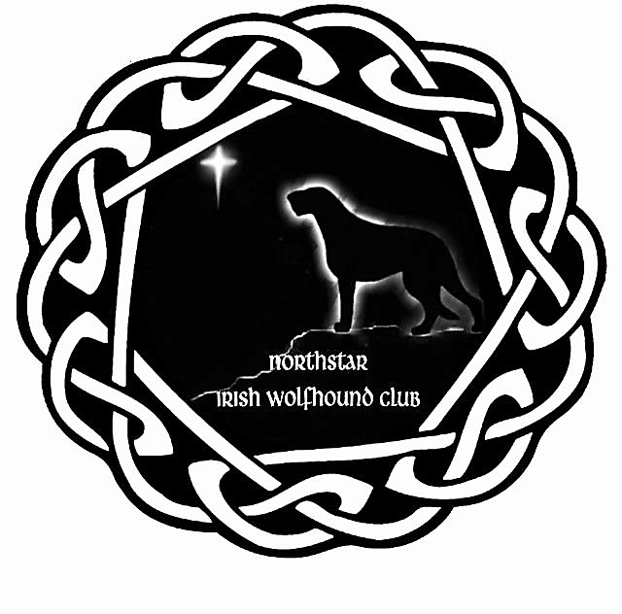
Associate Membership Application

Single Non-Voting, with newsletter $25.00
Name: ______________________________ Email Address: ___________________________
Address: ______________________________________________________________________
City, State, Zip Code: ____________________________________________________________
Telephone: ________________________ Mobile: _____________________________________
Please tell us about yourself. Do you currently own an Irish Wolfhound? _________ How many? ______
From whom did you obtain you Irish Wolfhound(s)? __________________________________________ _____________________________________________________________________________________
Are you a Companion owner? _______ Competitor/Exhibitor? ______Waiting for my first! __________
Have you ever bred a litter of puppies? _____ What breed? _______________ How many litters? _____
Areas of interest: (circle all) Community Events; Parades; Lure Coursing; Breed Education/Seminars; Obedience/Rally/Agility; Showing; Other; ___________________________________________________
Do you have any skills or training you would like to share with the Club? __________________________ _____________________________________________________________________________________
Are you acquainted with any current members of the Northstar Irish Wolfhound Club? (Names) _______ __________________________________________________________________________________________________________________________________________________________________________
Signature: _____________________________________________________________________
Please send application & check to: Marcia Miller, NIWC Secretary, 1372 W. Minnehaha Parkway, MN 55419
Membership Dues: __________________ Rescue Fund: ________________
A voluntary donation to the NIWC, used solely for the care of rescued IW
Total Enclosed: ___________________

Thank You for your application into the Northstar Irish Wolfhound Club. Your Membership will be voted on after two readings by the Board of Directors.

